PATIENT INFO
Name:
(LAST) (MI) (FIRST)
Address:
(STREET) (CITY) (STATE) (ZIP)
Cell Phone: Primary Pharmacy: Pharmacy Phone #:
Email Address:
DOB: / / Soc. Sec #: - -
Driver’s License #: State:
Marital Status: S M W Spouse’s Name:
Your Employer: Occupation:
Employer Address:
(STREET) (CITY) (STATE) (ZIP)

Referred By: Primary Care Physician:
INSURANCE INFORMATION
Insurance Type: Health Personal Pay PI/Auto Worker’s Comp Medicare
Insurance Name:
Member #: Group #:
Insurer’s Name (If Different from Patient): Relationship to Patient:
Insurer’s DOB: / / Insurer’s Soc. Sec #: - -
Insurer’s Employer:
Person responsible for account:

I clearly understand and agree that all services rendered to me are charged directly to me and that I am personally responsible for payment. I also understand that if I suspend or terminate my care and treatment, any fees for professional services rendered to me will be immediately due and payable.

Patient/Guardian Signature Date:

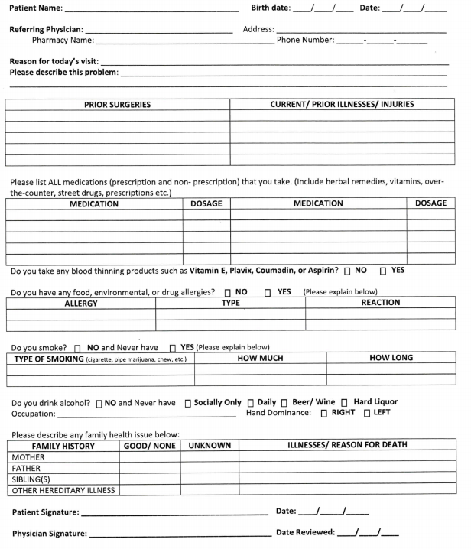

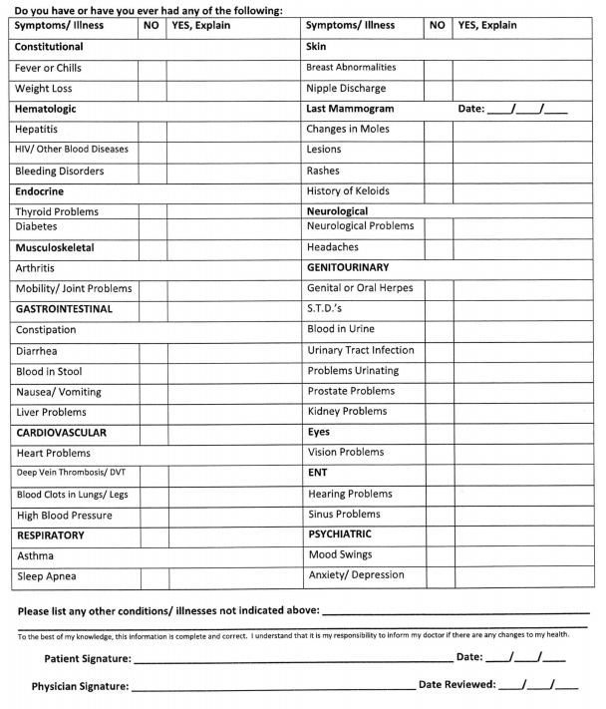

Informed Consent

Dear Patient:

Every type of health care is associated with some risk of a potential problem. This includes chiropractic care. We want you to be informed about potential problems associated with chiropractic health care before consenting to treatment. This is called informed consent.

Chiropractic adjustments are the moving of bones with the physician’s hands or with the use of a machine. Frequently, adjustments create a “popping” or “clicking” sound/sensation in the areas being treated.

In this office, we use trained assistants who may assist the physician with portions of your consultation, examination, x-ray taking, physical therapy application, traction, massage therapy, exercise instruction, etc. On the occasion when your physician is unavailable, your care may be handled by another physician or trained assistant.

Stroke: Stroke is the most serious problem associated with chiropractic adjustments. Stroke means that a portion of the brain does not receive oxygen from the blood stream. The results can be temporary or permanent dysfunction of the brain, with a very rare complication of death. The chiropractic adjustment that is related to the vertebral artery stroke is called Extension-Rotation-Thrust Atlas Adjustment. We DO NOT use this type of adjustments on our patients. Other type of neck adjustments may also potentially be related to vertebral artery strokes, but no one is certain. The most revelant studies (Journal of the CCA Vol. 37, No. 2, June 1993) estimate that the incidence of this type of stroke is 1 per every 3,000,000 upper neck adjustments. This means that an average chiropractic would have to be in practice for hundreds of years before they would statistically be associated with a single patient stroke.

Disk Herniations: Disk herniations that create pressure on a spinal nerve or the spinal cord are frequently successfully treated by chiropractors and chiropractic adjustment, traction, etc. This includes both in the neck and back. Yet, occasionally, chiropractic treatment (adjustments, traction, etc.) will aggravate the problem and rarely, surgery may cause a disk problem if the disc is in a weakened condition. These problems occur so rarely that there are no available statistics to quantify their probability.

Soft Tissue Injury: Soft tissue primarily refers to muscles and ligaments. Muscles move bones and ligaments limit joint movement. Rarely, a chiropractic adjustment (or treatment) may tear some muscle or ligament fibers. The result is a temporary increase in pain and necessary treatments for resolution, but there are no long term affects for the patient. These problems occur so rarely that there are no available statistics to quantify their probability.

Rib Fractures: The ribs are found only in the thoracic spine or mid-back. They extend from your back to your front chest area. Rarely, a chiropractic adjustment will crack a rib bone and this is referred to as a fracture. This occurs only on patients who have weakened bones from conditions such as osteoporosis. Osteoporosis can be detected on your x-rays. We adjust all patients very carefully,

and especially with those who have osteoporosis on their x-rays. These problems occur so rarely that there are no available statistics to quantify their probability.

Physical Therapy Burns: Some machines we use generate heat. We also use both heat and ice, and occasionally recommend them for home use. Everyone’s skin has different sensitivity to these modalities and rarely, heat or ice can burn or irritate the skin. The result is a temporary increase in skin pain, and there may be some blistering of the skin. These problems occur so rarely that there are no available statistics to quantify their probability.

Soreness: It is common for chiropractic adjustments, traction, massage therapy, exercise, etc., to result in a temporary increase in soreness in the region being treated. This is nearly always a temporary symptom that occurs while your body is undergoing therapeutic change. It is not dangerous, but if it occurs, be sure to inform your physician.

Other Problems: There may be other problems or complications that might arise from chiropractic treatment other than those noted above. These other problems or complications occur so rarely that it is not possible to anticipate and/or explain them all in advance of treatment.

Chiropractic is a system of health care delivery, and therefore, as with any health care delivery system, we cannot promise a cure for any symptom, disease, or condition as a result of treatment in this clinic. We will always provide you with the best care and if results are not acceptable, we will refer you to another health care provider who we feel may assist your condition.

If you have any questions on the above information, please ask your physician. Once you have a full understanding, please sign and date below.

Emergency Contact Name: _______________________________________________________

Emergency Contact Phone Number: ________________________________________________

Secondary Number:
________________________________________________

Patient Name (Printed) _____________________________________ Date ________________

Patient Signature ______________________________________________________________

Parent/Guardian Signature_______________________________________________________

Witnessed By _____________________________________________ Date _______________

Insurance Verification Disclosure/Agreement

As a courtesy, Path to Wellness will verify and file my health insurance. However, verification of my insurance benefits does NOT guarantee payment for services rendered. As such, in the event of my health insurance non-payment or limitations, I am financially responsible for all charges incurred.

Patient Name (Printed) _______________________________ Date ________________

Patient Signature ________________________________________________________

Parent/Guardian Signature ________________________________________________

Office Manager ______________________________________ Date ________________

Assignment of Benefits

The undersigned patient and/or responsible party, in addition to continuing personal responsibility, and in consideration of treatment rendered or to be rendered, grants and conveys for deferred payment to Path to Wellness Health, PLLC, a lien and assignment against the proceeds of the patient’s insurance settlement with all the following rights, power, and authority:

RELEASE OF INFORMATION: You are authorized to release information concerning my condition and treatment to my insurance company, attorney or insurance adjustor for purposes of processing my claim for benefits and payment for services rendered to me.

IRREVOCABLE ASSIGNMENT OF RIGHTS: You are assigned the exclusive, irrevocable right to any cause of action that exists in my favor against any insurance company for the terms of the policy, including the exclusive, irrevocable right to receive payment for such services, make demand in my name for payment, and prosecute and receive penalties, interest, court loss, or other legally compensable amounts owned by an insurance company in accordance with Article 21.55 of the Texas Insurance Code to cooperate, provide information as needed, and appear as needed, wherever to assist in the prosecution of such claims for benefits upon request.

DEMAND FOR PAYMENT: To any insurance company providing benefits of any kind to me/us for treatment rendered by the physician/facility named above within 5 days following your receipt of such bill for services to the extent of such bills are payable under the terms of the policy. This demand specifically conforms to Sec. 542.057 of the Texas Insurance Code, and Article 21.55 of the Texas Insurance Code, providing for attorney fees, 18% penalty, court cost, and interest from judgment, upon violation. I further instruct the provider to make all checks payable to Path to Wellness Health, PLLC, and to 525 Bailey Ave., Ft. Worth, TX 76107.

THIRD PARTY LIABILITY: If my injuries are the result of negligence from a third party, then I instruct the liability carrier to issue a separate draft to pay in full all services rendered, payable directly to Path to Wellness Health, PLLC, and to send any and all checks to 525 Bailey Ave., Ft. Worth, TX 76107.

STATUTE OF LIMITATIONS: I waive my rights to claim any statute of limitations regarding claims for services rendered or to be rendered by the physician/facility named above, in addition to reasonable cost of collection, including attorney fees and court cost incurred.

LIMITED POWER OF ATTORNEY: I hereby grant to the physician/facility named above power to endorse my name upon any checks, drafts, or other negotiable instrument representing payment from any insurance company representing payment for treatment and healthcare rendered by the physician/facility named above. I agree that any insurance payment representing an amount in excess of the charges for treatment rendered will be credited to my/our account or forwarded to my/our address upon request in writing to the physician/facility named above.

REJECTION IN WRITING: I hereby authorize the physician/clinic named above to establish a PIP or UM/UIM claim on my behalf. I also instruct my insurance carrier to provide upon request to the provider/clinic named above, any rejections in writing as they apply to my lack of PIP or UM/UIM coverage. I allege that electronic signatures are not adequate proof of rejection, and are invalid to establish rejection, and instruct my carrier to provide only copies of my original signature regarding rejection as evidence of rejection of PIP or UM/UIM.

TERMINATION OF CARE: I hereby acknowledge and understand that if I do not keep appointments as recommended to me by my caring doctor at this clinic, he/she has full and complete right to terminate responsibility for my care and relinquish any disability granted me within a reasonable period of time. If during the course of my care, my insurance company requires me to take an examination from any other doctor; I will notify this physician/facility immediately. I understand the failure to do so may jeopardize my case.

By my signature be it known that I have read and fully understand the above contract.

Patient Name (Printed) _______________________________Date _________________

Patient Signature ________________________________________________________

Parent/Guardian Signature _________________________________________________

Office Manager _____________________________________Date _________________

HIPAA Disclosure

Standard Authorization of Use and Disclosure of Protected Health Information
Information to Be Used or Disclosed

The information covered by this authorization includes:

- All Patient Medical Records

- Persons Authorized to Use or Disclose Information
  - Information listed above will be used or disclosed by:
    - PATH TO WELLNESS HEALTH, PLLC

- Personal Representative
  - Name: _____________________ Relationship: ______________________
  - Name: _____________________ Relationship: ______________________
    - I hereby authorize the request and release of Protected Health Information (PHI) held by Path to Wellness Health, PLLC. To the above personal representative. By appointing the person named on this form as a personal representative, I understand that I am authorizing Path to Wellness Health, PLLC. To give this person access to PHI, the right to talk to Path to Wellness Health, PLLC. about my care, and the right to make decisions that will bind me.

- Expiration Date of Authorization
  - This authorization is effective through _________ unless revoked or terminated by the patient or patient’s personal representative.

- Right to Terminate or Revoke Authorization
  - You may revoke or terminate this authorization by submitting a written revocation to this office and contact the Privacy Officer.

I understand this office will not condition my treatment or payment on whether I provide authorization for the requested use or disclosure.

I have read the above and hereby authorize Office Manager to use my protected information for the listed reasons.

Patient Name (Printed) _______________________________ Date _____________________

Patient Signature _____________________________________________________________

Parent/Guardian Signature ______________________________________________________

Office Manager ______________________________________ Date ____________________

Patient Communication Consent Form

I agree to allow Path to Wellness to contact me in the following methods regarding my private health information, lab results, evaluation, and treatment. I authorize Path to Wellness to leave messages for me when I am unavailable.

METHOD NUMBER/ADDRESS MESSAGE (Yes or No)

Home Phone |  | Yes | No
Cell Phone |  | Yes | No
Work Phone |  | Yes | No
Email |  | Yes | No

By my signature below I acknowledge that a copy of the Notice of Privacy Policies for Path to Wellness has been made available to me and I understand the Information provided on this consent form. I understand the risk associated with the different methods of communication (especially e-mail), and consent to the conditions, restrictions, and patient responsibilities outlined within the guideline.

Patient Name Date

Patient / Authorized Signature Date

FINANCIAL POLICY
Please initial next to each section indicating your acknowledgement:
___________All current balances, co-payments, co-insurance and deductibles are due and payable PRIOR to services being rendered and is required by your insurance to be paid at each visit. We accept cash, check, VISA, MasterCard, Discover, and American Express. We do not accept post-dated checks.
___________REFERRALS: If you have a managed care plan, an HMO, or similar plan that requires a referral, you will need a referral from your primary care physician to see our providers. If your insurance requires a referral that is generated through them, you must reach out to your primary care office for them to call your insurance. It is not our policy to generate a referral for ourselves. If we have not received this referral prior to your arrival at our office, your appointment will either be rescheduled or you may be responsible for the entire bill. It is your responsibility to know if a referral is required and to obtain one.
___________INSURANCE BENEFITS: Please be aware that when a patient requires a visit to a health care provider, there are diagnostic tests or procedures that may be suggested for appropriate care that may be done by one of our providers. These procedures may be done during the normal course of the exam by specialized personnel. Although necessary as part of routine evaluations, insurance companies often categorize these as procedures. The possible procedures which often are performed in this practice during your visit include, but are not limited to:
Trigger Point Injections B-12 Injections
Allergy Testing IV Therapies
EKG Evaluations Joint Injections
PRP/Amnio therapies Physical Rehabilitation/PT
Depending on your insurance policy provisions, these procedures and others may fall under a separate benefit other than your office co-pay, such as a deductible or coinsurance. In most cases, exact insurance benefits cannot be determined until the insurance company receives the claim. Therefore, any estimate for services will be considered an estimate only and any payment will be considered a partial-payment only until such time that the insurance company processes your claim. Your insurance is a contract between you and your insurance carrier; payment for services is ultimately your responsibility. It is extremely important for you to know your coverage. Many of the diagnostic and therapeutic procedures performed in our office (such as those listed above and others) are considered additional costs by your insurance company. Your health care providers are not aware of what additional costs may be incurred and will not review that with you. As health care providers, our physicians may recommend a diagnostic or therapeutic procedure available only to specialist physicians in order to provide you with the best possible treatment. If you have concerns regarding the cost of any procedure, you may ask your doctor if you can discuss the cost with our business staff BEFORE the procedure is performed to decide if you would like to have it done.
___________WAIVER OF CONFIDENTIALITY: You understand if this account is submitted to an attorney or collection agency, if we have to litigate in court, or if your past due status is reported to a credit reporting agency, the fact that you received treatment and the type of treatment received at our office may become a matter of public record or disclosed to third parties.

___________ DIVORCE: In case of divorce or separation, the party responsible for the account prior to the divorce or separation remains responsible for the account. After a divorce or separation, the parent authorizing treatment for a child will be the parent responsible to us for those subsequent charges.
___________ TRANSFERRING OF RECORDS: You will need to request in writing, and pay a reasonable copying fee (currently $25 for the first 40 pages and $0.10 a page there after) PRIOR to sending copies of your records to another doctor or organization. You authorize us to include all relevant information, including your payment history and hereby indemnify and hold us harmless for any claims or damages resulting from our providing records pursuant to your request. If you request records to be transferred from another doctor or organization to us, you authorize us to receive all relevant information, including your payment history.
___________ PERSONAL INJURY: If you are being treated as part of a personal injury lawsuit or claim, we require verification from your attorney prior to your initial visit. Payment of the bill remains the patient’s responsibility.
___________ LIABILITY: If you are being treated for a 3rd party liability claim and do not have an attorney, we will require that you allow us to bill your health insurance or file on your Personal Injury Protection. Upon settlement of your claim, YOU WILL BE RESPONSIBLE FOR ANY BALANCE OWED ON YOUR ACCOUNT REGARDLESS OF THE AMOUNT OF SETTLEMENT YOU RECEIVE FROM THE INSURANCE COMPANY. Please understand upon settlement of your claim, the 3rd party carrier will NOT PAY US DIRECTLY; however, you remain fully responsible for payment of your account. If you do not have health insurance or PIP, we must have a letter of protection on file from an attorney. Otherwise, you will be responsible for payment in full at the time services are rendered. We have the right, at our sole discretion, to refuse to accept a letter of protection for payment of your services.
___________ FORMS FEE: Please allow 5-7 business days to complete all forms that require a physician signature and medical review (i.e., Worker’s Comp, FMLA, Short-term disability (STD), other extended leave of absence, etc.) The physician must take the time to fill out the forms and as such may charge for each record requested, a $30.00 Forms Fee. Each time a correction needs to be made to a form, another Forms Fee will be charged to the account. There is no exception to this rule. Additional medical records request will also have a $40.00 assigned fee.
___________ NO SHOW/CANCELLATION COURTESY: We are committed to making you an appointment at your earliest convenience; likewise, we require a call at least 24 hours in advance if you are unable to keep your appointment to allow for other patients to be seen. If you “no show” for an appointment or cancel with less than 24 hours’ notice, you will be charged a $35.00 fee. Multiple missed appointments may result in our request for you to find another provider.
___________ RETURNED CHECK FEE: There is a $35.00 fee for checks returned for any reason and will be added to your original balance. In addition, we may seek all additional legal remedies provided to us under Texas law.
___________ PATIENT BALANCE POLICY: After filing with the insurance company, we will promptly mail you a patient statement. Payment in full is due upon receipt of this statement and is a courtesy from our office. If you have any questions or dispute the balance, it is your responsibility to contact our billing office within 30 days. Accounts past 90 days will be considered past due and may be referred to outside resources for further management. If you are unable to pay the balance due in full, you must contact our billing office to discuss a payment schedule or arrangements. Any late fees incurred on past due balances will be included in any mutually agreed upon arrangements.
___________ BANKRUPTCY: If we attempt to collect a debt and you have filed for bankruptcy, and we are listed as a creditor, please advise us of this and we will cease collection activity immediately.

Patient Name: ________________________________________Date: ____________

Parent/Guardian Name: _________________________________________________

Patient Signature: _____________________________________________ (Parent/Guardian if minor)

